Adaptive LLM Tutors: Personalized Coaching from Interaction Evidence
Team member: Joyce Zhou (zy1226), Yuan Tian (ytian24), Chengxun Ren (cren8)

1. Problem Definition and Motivation
Users of AI agents can need different guidance after the same mistake: one learner may need a worked example of source verification, another only a reminder of a rule they know. We ask whether combining observed behavior with AI-literacy background, defined as the competencies to critically evaluate and effectively collaborate with AI systems (Long & Magerko, 2020), helps a coaching agent choose more appropriate practice. The coach may also decide not to intervene: a novice who skips verifying a source might receive a demonstration, while a self-correcting expert receives none.
We focus on four observable behaviors:
- Stating deliverable requirements: specifying “one page, three bullets for a manager” instead of “summarize this.”
- Stating evidence requirements: ask AI to name the source column for every figure.
- Selecting a claim to check: when the AI says the score rose 35%, ask it to verify that number against the table.
- Correcting an output after finding a problem: noticing the figure should be 28% and asking the AI to fix it and explain the error.
We assess interaction episodes, including those with no relevant opportunity or insufficient evidence. Background describes prior AI-related knowledge, not a fixed skill label. This human-centered project evaluates coaching decisions and their effects on simulated learners.
RQ1 (Verify): How reliably can an LLM judge whether a user performed the behavior, missed it, or lacked a contextual trigger to do so at a decision point?
RQ2 (Apply): Can an LLM choose effective coaching for simulated learners with different AI-literacy backgrounds?

2. Comparison with Existing Work
Our measurement component builds on research that makes collaboration behavior observable. CollabSkill and the AI Fluency Index provide behavioral indicators (Shao et al., 2026; Anthropic, 2026), while CLAMBER evaluates ambiguity identification and clarification (Zhang et al., 2024). We use these ideas to assess the evidence available for a coaching decision.
The intervention builds on collaboration-rule onboarding and learning-aware decision support (Mozannar et al., 2023; Buçinca et al., 2024). We test whether behavioral evidence and learner background together improve coaching outcomes, rather than using memory to adapt the task agent to user preferences (Mehri et al., 2026). Shen and Tamkin (2026) motivate separating assisted task completion from subsequent assessment.
User simulation allows controlled comparisons across learner profiles. Prior work represents mastered, confused, and unknown knowledge or reproduces specific misconceptions (Lu & Wang, 2024; Sonkar et al., 2024). We adapt these principles to AI-literacy profiles and check their baseline behavior before testing coaching, given documented simulator-fidelity gaps (Zhou et al., 2026).

3. Next Steps and Direction
Data and study sequence
The public CollabSkill release contains 386 session files, including 61 without extractable logs, leaving 325 parseable histories. We will sample about 60 assessment episodes across the four behaviors, participants, and agents as a pilot, adjusting the target after checking observability. RQ1 uses these real histories to validate the assessment module. Building on this module, RQ2 moves to a controlled simulation with LLM learners whose initial AI-literacy profiles are specified.
Part A: Measurement
RQ1: Validating behavioral assessments
We will build a human reference set using two independent annotators. Each episode will be labeled as performed (2), partial (1), or missed despite a clear opportunity (0), with N/A used for absent opportunities or insufficient evidence and the reason recorded. A third adjudicator will resolve disagreements; human-human agreement will be calculated from the original independent labels. After fixing prompts on the development set, we will evaluate the assessment module on participant-disjoint test data, measuring agreement with the adjudicated labels and the rate of incorrectly labeling non-missed cases as missed.
RQ2: Evaluating coaching through user simulation
We will define novice, intermediate, and expert LLM-simulated learners through their initial AI-related knowledge and misconceptions and check their behavior on pilot tasks. Each learner will complete a pre-task with an AI task agent. The assessment module evaluated in RQ1 will then assess the learner’s interaction, labeling the four target behaviors with supporting evidence.
We will create four independent copies of the learner’s completed pre-task state: the full coaching system with assessment and background, a version without explicit assessment, a version without background, and a no-coaching control. The learner model, initial profile, and pre-task history will be identical across branches. All three coaching systems will receive the same task and raw interaction and share an exercise bank and maximum interaction budget. Each coach will select one exercise or no coaching.
Each branch will then complete the same matched post-task with new content, retaining its history but receiving no further coaching. A separate evaluator, blinded to condition, will score both tasks using fixed rubrics. We will compare post-minus-pre gains in percentage of available rubric points across conditions within each profile over repeated runs. Secondary measures will include coaching acceptability rated by blinded human annotators, targeted-error rates, and coaching turns.
Part B: Analysis
We will compare successful and unsuccessful cases to examine how assessment errors affect coaching choices and whether learners apply guidance to the new task. Within each profile, we will inspect mismatched support, persistent misconceptions, and high baseline scores as possible explanations for limited gains. This connects the numerical comparisons to specific interaction patterns.

References
Anthropic. (2026). Anthropic education report: The AI fluency index. Anthropic. https://www.anthropic.com/research/AI-fluency-index
Buçinca, Zana, Swaroop, Siddharth, Paluch, Amanda E., Murphy, Susan A., & Gajos, Krzysztof Z. (2024). Towards optimizing human-centric objectives in AI-assisted decision-making with offline reinforcement learning. arXiv. https://arxiv.org/abs/2403.05911
Long, D., & Magerko, B. (2020). What is AI literacy? Competencies and design considerations. Proceedings of the 2020 CHI conference on human factors in computing systems.
Lu, Xinyi, & Wang, Xu. (2024). Generative students: Using LLM-simulated student profiles to support question item evaluation. Proceedings of the Eleventh ACM Conference on Learning @ Scale. Association for Computing Machinery. https://doi.org/10.1145/3657604.3662031
Mehri, Shuhaib, Kargupta, Priyanka, August, Tal, & Hakkani-Tür, Dilek. (2026). MultiSessionCollab: Learning user preferences with memory to improve long-term collaboration (Version 3). arXiv. https://arxiv.org/abs/2601.02702v3
Mozannar, Hussein, Lee, Jimin J., Wei, Dennis, Sattigeri, Prasanna, Das, Subhro, & Sontag, David. (2023). Effective human-AI teams via learned natural language rules and onboarding. Advances in Neural Information Processing Systems, 36. https://arxiv.org/abs/2311.01007
Shao, Yijia, Wang, Zora Zhiruo, Ahuja, Neel, Wang, Yicheng, Liu, Bowen, & Yang, Diyi. (2026). CollabSkill: Evaluating human-agent collaboration on real-world tasks. Proceedings of the Third Conference on Language Modeling. https://arxiv.org/abs/2606.09833
Shen, Judy Hanwen, & Tamkin, Alex. (2026). How AI impacts skill formation. arXiv. https://arxiv.org/abs/2601.20245
Sonkar, Shashank, Chen, Xinghe, Liu, Naiming, Baraniuk, Richard G., & Sachan, Mrinmaya. (2024). LLM-based cognitive models of students with misconceptions. arXiv. https://arxiv.org/abs/2410.12294
Zhang, Tong, Qin, Peixin, Deng, Yang, Huang, Chen, Lei, Wenqiang, Liu, Junhong, Jin, Dingnan, Liang, Hongru, & Chua, Tat-Seng. (2024). CLAMBER: A benchmark of identifying and clarifying ambiguous information needs in large language models. Proceedings of the 62nd Annual Meeting of the Association for Computational Linguistics (Volume 1: Long Papers), 10746–10766. Association for Computational Linguistics. https://aclanthology.org/2024.acl-long.578/
Zhou, Xuhui, Sun, Weiwei, Ma, Qianou, Xie, Yiqing, Liu, Jiarui, Du, Weihua, Welleck, Sean, Yang, Yiming, Neubig, Graham, Wu, Sherry Tongshuang, & Sap, Maarten. (2026). Mind the Sim2Real gap in user simulation for agentic tasks. Proceedings of the Third Conference on Language Modeling. https://arxiv.org/abs/2603.11245
AI-Use Disclosure Statement
LLM assistance was used to discuss and refine research questions and improve the clarity and wording of this proposal. No AI tools were used for coding or experiments at this stage.
Appendix A: Research Pipeline
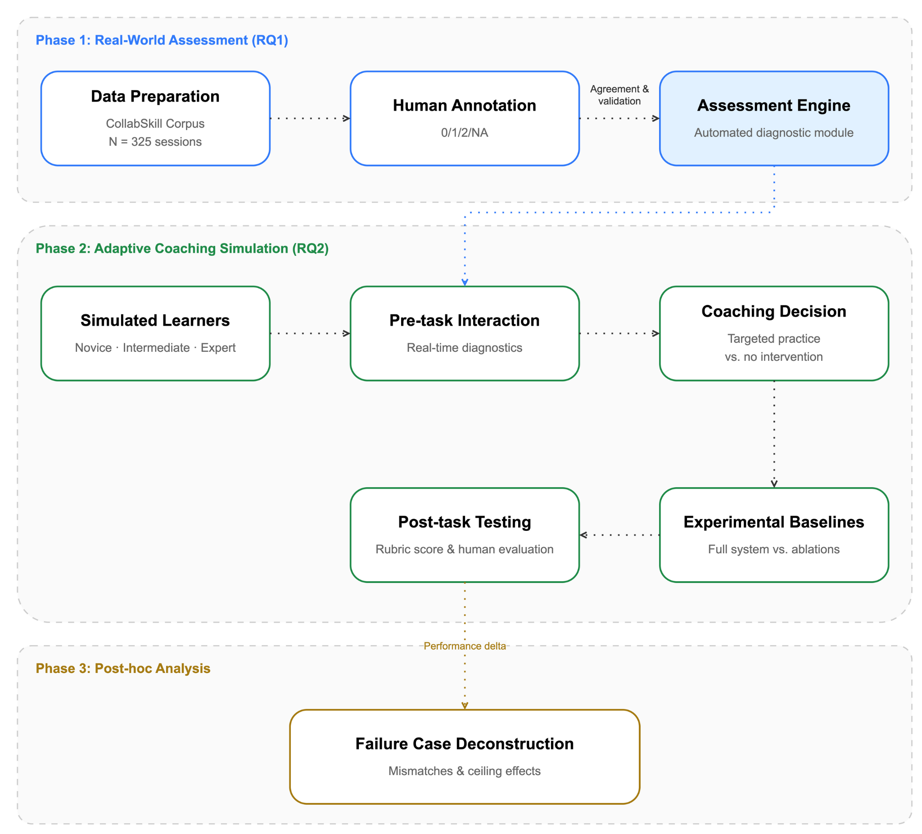

Protocol:
Specification and Verification Behaviors
1. Purpose and unit of annotation We label whether a user performed, partially performed, or missed one of four behaviors at a decision point: a moment in a session where the user had a concrete chance to perform that behavior. We label the event, not the person. A 0 never means “this user lacks the skill.” Only use what is visible: the task prompt (from tasks.json), and the dialogue up to and including the user turn being judged. Do not use later turns to decide whether the user could have acted. Ignore empty user messages and messages starting with “/” (command-line instructions).

2. Labels
Label | Meaning
2 | The user clearly performed the behavior, specifically enough that a third person could tell what was asked.
1 | The user performed it only partly: generic, vague, or incomplete.
0 | A concrete opportunity was visible in the dialogue and the user did not act on it.
N/A | No opportunity existed, or we cannot judge from visible material. A reason is required.
Tie-breakers (use these before discussing):
- 1 vs 2: Apply the behavior-specific criteria in Section 3 first. For B1, label 2 requires at least two concrete deliverable properties; one concrete property receives 1, even if clearly specified. For B2, label 2 requires a specific evidence request. For B3, label 2 requires targeting a specific checkable claim. For B4, label 2 requires identifying a specific problem and providing a concrete correction or intended fix. Otherwise, use 1 when the behavior is present but generic or incomplete.
- 0 vs N/A: Was there a concrete thing, visible in the dialogue, that the user could have acted on? If yes, label 0; if not, label N/A.

3. The four behaviors
B1. Stating deliverable requirements. The user states what the output should look like (format, length, audience, required content, constraints).
- Decision point: the opening request, or any later request for a new or revised output.
- 2: Names at least two concrete properties. Illustrative: “A one-page summary for a manager, three bullets, no jargon.”
- 1: Names one property or only vague qualities. “Make it professional.”
- 0: A bare request with no properties, and the task prompt does not already supply them. “Summarize this.”
- N/A: Requirements sit in attached or pasted material we cannot see, or the task prompt already fully specifies them.
B2. Stating evidence requirements. The user states how claims should be supported (sources, calculations, citations, justification).
- Decision point: a request whose output will contain factual claims, figures, or analysis.
- 2: Asks for specific evidence. “Give the source column for each figure.”
- 1: Asks generically for accuracy. “Check for mistakes and be accurate.”
- 0: The request produces claims that need support, and no evidence requirement is stated, even though the task prompt does not supply sources.
- N/A: The task supplies the sources, the output contains no factual claims, or the relevant instruction is in unseen material.
B3. Selecting a claim to check. The user picks a specific claim in the agent’s output and checks it or asks that it be checked.
- Decision point: the user’s response to an agent output that contains a concrete, checkable claim.
- 2: Targets a specific claim and verifies it or asks for verification. “Where does the 35% come from? Recalculate it.”
- 1: Asks for a general re-check without targeting anything. “Double-check everything.”
- 0: The output contains a concrete checkable claim and the user accepts it or moves on. “Thanks, next.”
- N/A: The agent output has no checkable claim yet (a clarifying question, a progress message), or the session ends before any user response.
- Note: If the user identifies a specific checkable claim from an agent-generated artifact and questions or challenges it, label 2 even when the artifact itself is unavailable. Judge the observable checking behavior, not whether the user's challenge is factually correct. If neither the visible agent output nor the user's message establishes an identifiable checkable claim, use N/A when the opportunity cannot be determined.
- Note: A general request to check the accuracy of an entire document, all calculations, or all citations receives 1, provided a checkable agent output is established. A request that identifies a particular factual statement, number, or regulatory claim and asks for verification receives 2. Requests for evidence to support a new output should be evaluated under B2 rather than automatically counted as B3.
B4. Correcting an output after finding a problem. The user addresses a problem in the agent’s output.
- Decision point: only where a problem is visible at or before the user’s turn (the agent acknowledges an error, the output visibly contradicts the task prompt, a tool result shows failure, or the user points it out).
- 2: Names the specific problem and what to fix. “The weightage table is missing after the sentence ‘Suppliers are evaluated…’; insert it there.”
- 1: States dissatisfaction without specifics. “This is wrong, try again.”
- 0: The problem is visible in the dialogue and the user does not address it.
- N/A: No problem is visible. Later complaints do not make an earlier turn a 0.
- Note: If the user identifies a specific problem and provides a concrete correction or correct interpretation, label 2 even without an explicit request to revise the output. Generic dissatisfaction without an identifiable correction receives 1.
- Note: A newly introduced constraint can establish a problem with an existing output when the mismatch is visible from the dialogue and the user requests a targeted adjustment. This can receive 2 under B4, but does not imply that the agent violated the original instructions. If the user merely adds a new requirement without addressing a problem in the existing output, evaluate it under B1 instead. Do not retrospectively treat earlier turns as missed correction opportunities.

4. Recording each decision point
Each row represents one decision point × behavior, not an entire conversation. If the same user turn involves multiple behaviors (e.g., B1 and B2), record them as separate rows, each with its own label and reason. The session_id and turn_id remain the same.
Column | Content
session_id | Folder name
turn_id | Turn of the user message judged
behavior | B1–B4
label | 2 / 1 / 0 / N/A
reason | One sentence
confidence | high / medium / low
unclear_rule | Free text if the protocol did not settle it
Do not copy file paths, names, or other identifying strings into the record. Paraphrase instead.

5. Sampling
- Draw sessions from those with at least two valid user turns (226), stratified by agent.
- Take at most two decision points per behavior per session, so long sessions do not dominate.
- Target about 60 decision points (roughly 15 per behavior); adjust after the pilot.

6. Procedure
- Pilot round 1: each annotator independently labels the same 10 decision points. Compare disagreements.
- Revise: for each disagreement, decide whether the rule was unclear (update the protocol) or the case is genuinely hard (note it).
- Pilot round 2: repeat on 10 new decision points.
- Freeze the protocol. No rule changes after this point.
- Main round: both annotators independently label all decision points.
- Report annotator agreement (raw agreement and Cohen’s kappa) before resolving disagreements. Then resolve by discussion and record the adjudicated label.
- The same frozen protocol is given to the LLM; LLM labels are compared with both the individual and adjudicated human labels.

Annotation workbook: https://docs.google.com/spreadsheets/d/1zKbKtL-_lk_jvbd8AxVVRR9ndYvXRVn7hgxJ0ZK0c3s/edit?gid=192025465#gid=192025465

Precedure:
1. pilot
Pilot round 1: each annotator independently labels the same 10 decision points. Compare disagreements.
Revise: for each disagreement, decide whether the rule was unclear (update the protocol) or the case is genuinely hard (note it). Record the reasons for disagreement and add examples or clarification where needed.
Pilot round 2: repeat on 10 new decision points. Check whether the revised rules reduce disagreements. If major issues remain, revise and repeat.
Freeze the protocol. No rule changes after this point.
2. main annotation
Main round: both annotators independently label all decision points.
Report annotator agreement (raw agreement and Cohen’s kappa) before resolving disagreements using the original independent labels. Then resolve by discussion and record the adjudicated label.
3. llm evaluation
The same frozen protocol is given to the LLM; LLM labels are compared with both the individual and adjudicated human labels.
Report raw agreement and Cohen’s kappa for LLM vs. each annotator and LLM vs. adjudicated labels.
Analyze disagreement patterns, especially cases where human annotators also disagreed.

Helping Users Learn to Collaborate with LLMs

1. Problem Definition and Motivation
An LLM can help someone finish a report without teaching them how to manage the next one. A student might receive a convincing draft despite having left the requirements vague or accepted claims without checking the evidence. Judging only the final document would miss whether the student has learned to specify and verify AI-assisted work.
Preference-based personalization uses interaction history to improve the agent’s behavior. We ask whether the same history can help the human become a better collaborator, with gains that persist after personalized coaching is removed. We will focus on specification and verification, scored through four behaviors: stating deliverable requirements, stating evidence requirements, selecting a claim to check, and correcting an output after finding a problem. These skills matter for students and early-career workers who use AI while developing their own judgment. Shen and Tamkin (2026) found that AI assistance could impair learning in an unfamiliar programming library. Their findings motivate evaluating what users learn alongside what they produce.
The project fits CS329X’s focus on human-agent collaboration and evaluation. Its main outcome is a change in the user’s behavior, alongside the quality of AI-assisted work. Coaching also has a cost: someone trying to learn may welcome a short exercise, while someone facing a deadline may prefer direct help. Users should be able to decline coaching.
Our main scientific question is whether coaching matched to observed collaboration difficulties improves later uncoached collaboration more than equally intensive general guidance. This is one intervention study: RQ1 is a measurement prerequisite, RQ2 captures immediate effects, and RQ3 is the primary outcome.
RQ1: How reliably can interaction histories support ratings of the four target behaviors?
RQ2: How does skill-matched coaching affect task quality, effort, and the target behaviors during practice?
RQ3: Does skill-matched coaching improve those behaviors on unfamiliar tasks with a standard LLM after coaching and personal memory are removed?

2. Comparison with Existing Work
Preference-based personalization provides one starting point. MultiSessionCollab uses memory to learn interaction preferences and evaluates their effects on collaboration quality (Mehri et al., 2026). Our endpoint is the user’s behavior with a standard assistant after personalized coaching and memory have been removed.
CollabSkill provides interaction records and behavior indicators from real occupational tasks (Shao et al., 2026). We will use these records to identify examples of effective specification and verification and turn selected decision points into short exercises. Our rubric will score behavior when the task provides an opportunity to perform it, distinguishing an observed difficulty from insufficient evidence.
Collaboration training is the closest methodological precedent. Mozannar et al. (2023) derive natural-language rules from collaboration data and teach them through onboarding. Buçinca et al. (2024) examine adaptive decision support with both accuracy and human learning as objectives. Our proposed contribution is to connect history-based diagnosis to the selection of practice and test whether this matching improves specification and verification behavior beyond general guidance. Performance after coaching ends is the main test.

3. Next Steps and Direction
We plan to use one task family: preparing decision briefs from supplied documents and a table. For RQ1, we will compare history-based model ratings with independent human ratings on held-out calibration tasks. Human-reviewed profiles will determine coaching targets in the pilot. This supplies a common measurement basis for the intervention and transfer comparison.
The prototype will offer brief, task-linked practice. For example, a verification exercise would ask the user to choose a claim, check it against a source or calculation, and revise the draft when warranted. Participants would be randomly assigned to skill-matched coaching or general guidance, using the same agent, exercise library, checkpoints, and practice budget. For RQ2, we will measure the four behaviors and deliverable quality; effort will be measured through completion time and self-reported mental effort. RQ3 will use a new task with a standard LLM and no coaching or personal memory. Raters unaware of condition will score the same four behaviors, with deliverable quality as a secondary outcome. This shared design links diagnosis, practice, and transfer to one primary comparison: whether matching coaching to observed needs improves later uncoached collaboration.
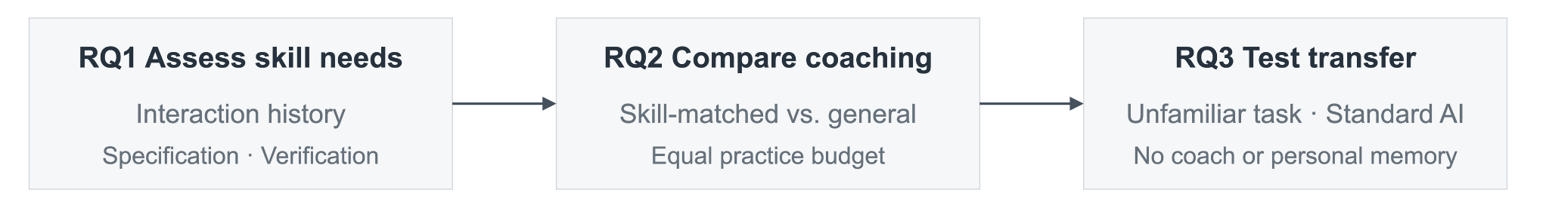
Figure 1. One intervention study: RQ1 provides measurement support, RQ2 captures practice effects, and RQ3 tests uncoached transfer as the primary outcome.

References
Buçinca, Zana, Swaroop, Siddharth, Paluch, Amanda E., Murphy, Susan A., & Gajos, Krzysztof Z. (2024). Towards optimizing human-centric objectives in AI-assisted decision-making with offline reinforcement learning. arXiv. https://arxiv.org/abs/2403.05911
Mehri, Shuhaib, Kargupta, Priyanka, August, Tal, & Hakkani-Tür, Dilek. (2026). MultiSessionCollab: Learning user preferences with memory to improve long-term collaboration. arXiv. https://arxiv.org/abs/2601.02702
Mozannar, Hussein, Lee, Jimin J., Wei, Dennis, Sattigeri, Prasanna, Das, Subhro, & Sontag, David. (2023). Effective human-AI teams via learned natural language rules and onboarding. Advances in Neural Information Processing Systems, 36. https://arxiv.org/abs/2311.01007
Shao, Yijia, Wang, Zora Zhiruo, Ahuja, Neel, Wang, Yicheng, Liu, Bowen, & Yang, Diyi. (2026). CollabSkill: Evaluating human-agent collaboration on real-world tasks. Proceedings of the Third Conference on Language Modeling. https://arxiv.org/abs/2606.09833
Shen, Judy Hanwen, & Tamkin, Alex. (2026). How AI impacts skill formation. arXiv. https://arxiv.org/abs/2601.20245

RQ1: How reliably can an LLM judge whether a user performed the behavior, missed it, or had no clear opportunity at a decision point?
RQ2: Does an LLM that reads the user’s dialogue choose coaching actions closer to human judgments than one that sees only the task?

Comment backup: Offline + Simulation
Verbatim comments and their original question context, saved before revising the Verify/Apply questions. This section is a backup, not part of the proposal above.
Original RQ1
RQ1: How reliably can an LLM judge whether a user performed the behavior, missed it, or had no clear opportunity at a decision point?
Comment 0: Joyce Zhou | 2026-10-14T23:19:35Z
RQ1：How reliably can an LLM judge... as measured by agreement with human annotators relative to human-human agreement, and by how often it wrongly labels a non-missed case as missed?
RQ2：Does an LLM that reads the user’s dialogue choose coaching actions closer to human judgments than one that sees only the task, measured by acceptable-action rate, unnecessary-coaching rate, and missed-coaching rate?
Comment 1: Joyce Zhou | 2026-10-15T01:01:10Z
ASPersna
Comment 2: Joyce Zhou | 2026-10-15T01:01:27Z
SWE
Original RQ2
RQ2: Does an LLM that reads the user’s dialogue choose coaching actions closer to human judgments than one that sees only the task?
Comment 3: Joyce Zhou | 2026-10-15T01:00:37Z
1.决定用什么策略去恢复

CollabSkill pilot annotation and Codex comparison
Exploratory analysis of 20 pilot items | Frozen codebook v0.2 | 27 October 2026
The main result is agreement on the straightforward cases and disagreement around a few rule boundaries. Codex matches both raters on all 17 items where A and B agree. Across all 20 items, it matches A on 19 and B on 18. This is useful for checking how the revised rules are being applied, but it is not a held-out accuracy estimate.
Important design limit: A and B used the original v0.1 rules, while Codex used frozen v0.2, written after the pilot disagreements were examined. Pilot 2 A was initially proposed by AI and then reviewed and confirmed by A. Keep these facts attached to the numbers below.

Notebook and reproducibility files
Open the executed notebook in Colab
Download/view the .ipynb
Executed HTML with all code and outputs
Reproducibility bundle: inputs, code, figures and run records
Annotation workbook
The notebook embeds all 20 annotation records and runs without external data or model calls. Its saved outputs include four figures, agreement tables and the disputed-item table. File-sharing settings have not been broadened; the owner may need to grant collaborators access to the notebook/bundle. The findings, figures and core Python below are included directly in this document.

1. What was run
Codex CLI 0.154.0, explicitly selecting gpt-5.6-sol with medium reasoning. Twenty separate ephemeral processes received the frozen protocol and one case each. No human labels, human reasons or Compare notes were supplied. Shell/web access was disabled, and the event logs contain zero tool calls. The CLI did not expose an immutable server-side model snapshot ID; this is a model-alias run, not a claim of a pinned backend snapshot.
v0.2 was frozen by explicit user authorization. Separate approval from B has not been documented. The freeze changed status metadata, not the substantive rules. Protocol SHA-256: 046ceb7bc8fb5035ebd347c56e3a16b4b8240deb4d3279904bf4a77bfb845e1d
The human labels and empty adjudication fields were copied from the live workbook after inference. N/A is treated as a fourth nominal label, not as missing data. We use raw agreement and unweighted Cohen’s kappa, and keep the two pilot rounds separate.

2. Agreement results
Round | Comparison | Matches | Agreement | Kappa
P1 | A vs B | 9/10 | 90% | 0.714
P1 | Codex vs A | 10/10 | 100% | 1.000
P1 | Codex vs B | 9/10 | 90% | 0.714
P2 | A vs B | 8/10 | 80% | 0.730
P2 | Codex vs A | 9/10 | 90% | 0.861
P2 | Codex vs B | 9/10 | 90% | 0.865
All (descriptive) | A vs B | 17/20 | 85% | 0.754
All (descriptive) | Codex vs A | 19/20 | 95% | 0.918
All (descriptive) | Codex vs B | 18/20 | 90% | 0.841
The combined rows are descriptive only. They mix two pilot samples and include AI-assisted A labels in Pilot 2. Agreement is not accuracy: no adjudicated reference is available, so LLM-versus-adjudicated agreement and kappa cannot yet be calculated.
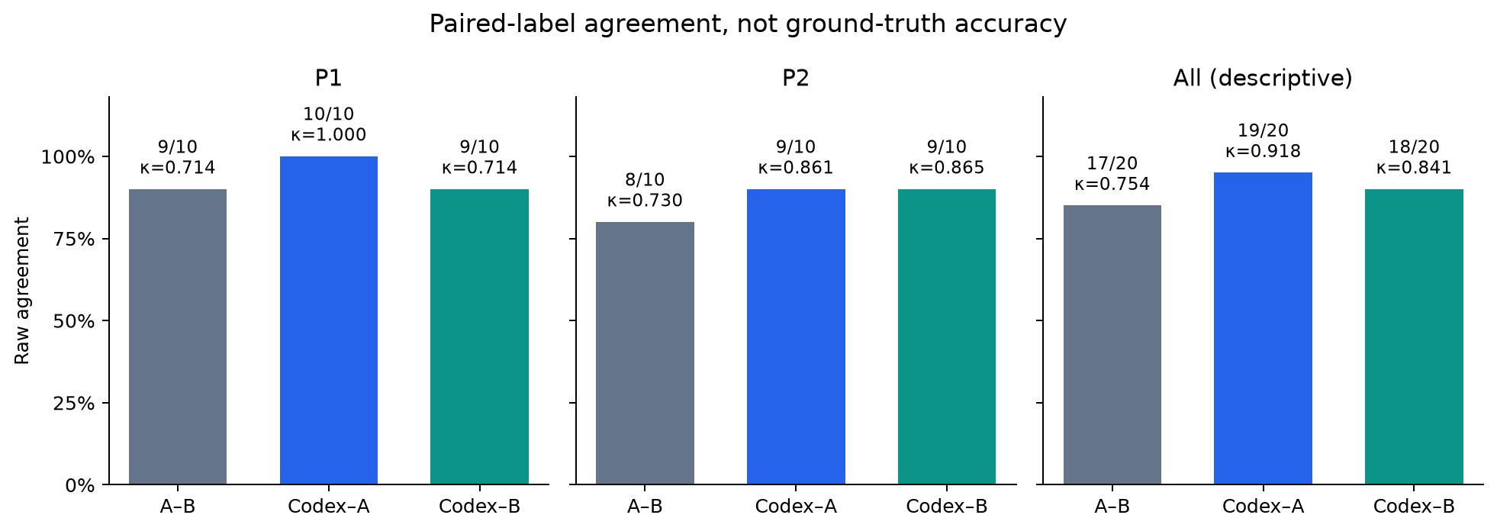
Figure 1. Agreement by round and overall. Pilot 2 A/B raw agreement is lower than Pilot 1 (80% versus 90%), even though kappa is slightly higher; different label frequencies explain why these statistics can move in opposite directions.

3. The three disputed cases
Item | Behavior | A | B | Codex
P1-02 | B2 | 0 | N/A | 0
P2-01 | B4 | N/A | 1 | N/A
P2-07 | B3 | 2 | 0 | 0
P1-02: Codex assigns 0. The visible request is treated as self-contained, so missing original-task metadata alone does not force N/A. No evidence standard is requested in the visible task.
P2-01: Codex assigns N/A. The user is supplying missing input files and asking to restart, not correcting an established problem in an output.
P2-07: Codex assigns 0. The user asks about downloading the image, not about the substantive growth figures. Under v0.2, a delivery-only question does not count as B3 verification.
These outcomes follow distinctions made explicit during the codebook revision. They are evidence that this run applied those distinctions, not an independent test that the distinctions or labels are correct. Codex labels have not been copied into the adjudication column.
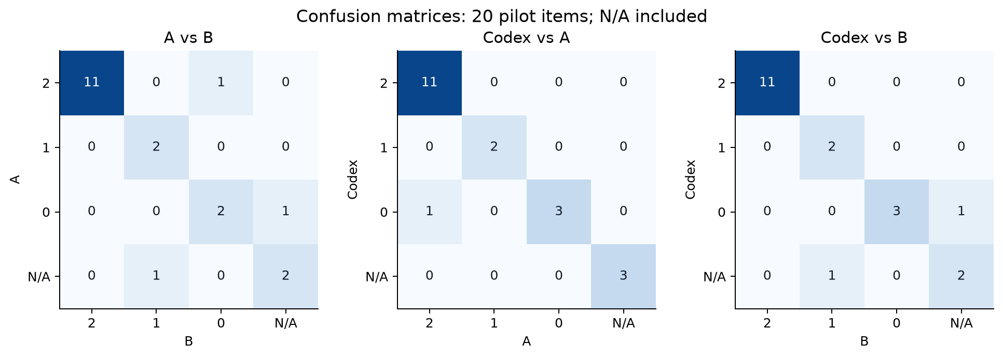
Figure 2. Confusion matrices over all 20 items, with N/A retained as a category. Axes identify the two raters; off-diagonal counts are disagreements.
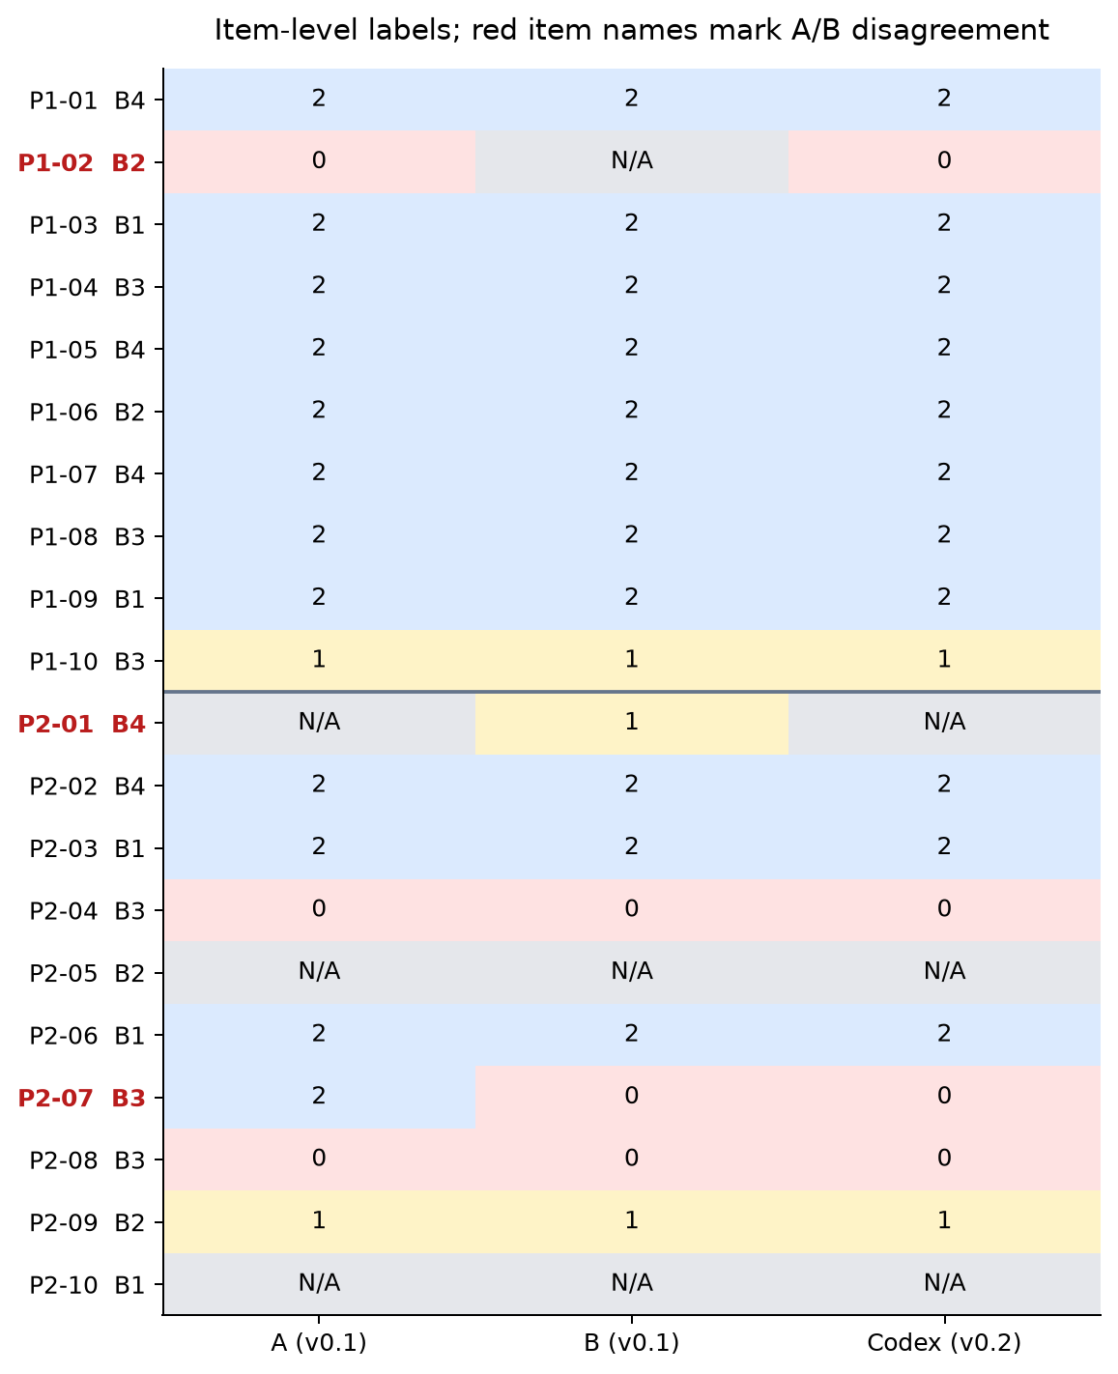
Figure 3. Every item’s label. Red item names mark the three A/B disagreements; the horizontal divider separates the pilot rounds.

4. What we can and cannot conclude
First, Codex matches the shared A/B label on all 17 consensus items. The remaining three are exactly the boundary cases already discussed by the team. This supports using these cases as codebook examples, but it does not show generalization to new conversations.
Second, the small behavior subsets limit interpretation. A/B agreement is 5/5 for B1, 3/4 for B2, 5/6 for B3 and 4/5 for B4. With only four to six items per behavior, these are counts to inspect rather than reliable rankings of difficulty or model capability.
Third, Codex reports high confidence on every item. Without an adjudicated reference, that cannot be interpreted as calibrated confidence. The absence of uncertain model outputs does not remove uncertainty from the study design.
Fourth, the next useful test is a fresh sample labeled independently by two humans under the same frozen v0.2, with no model suggestions. Report their agreement before discussion, then compare a blinded Codex run with each human and the adjudicated reference. Do not overwrite these original pilot labels or report this cross-version comparison as an independent main evaluation.
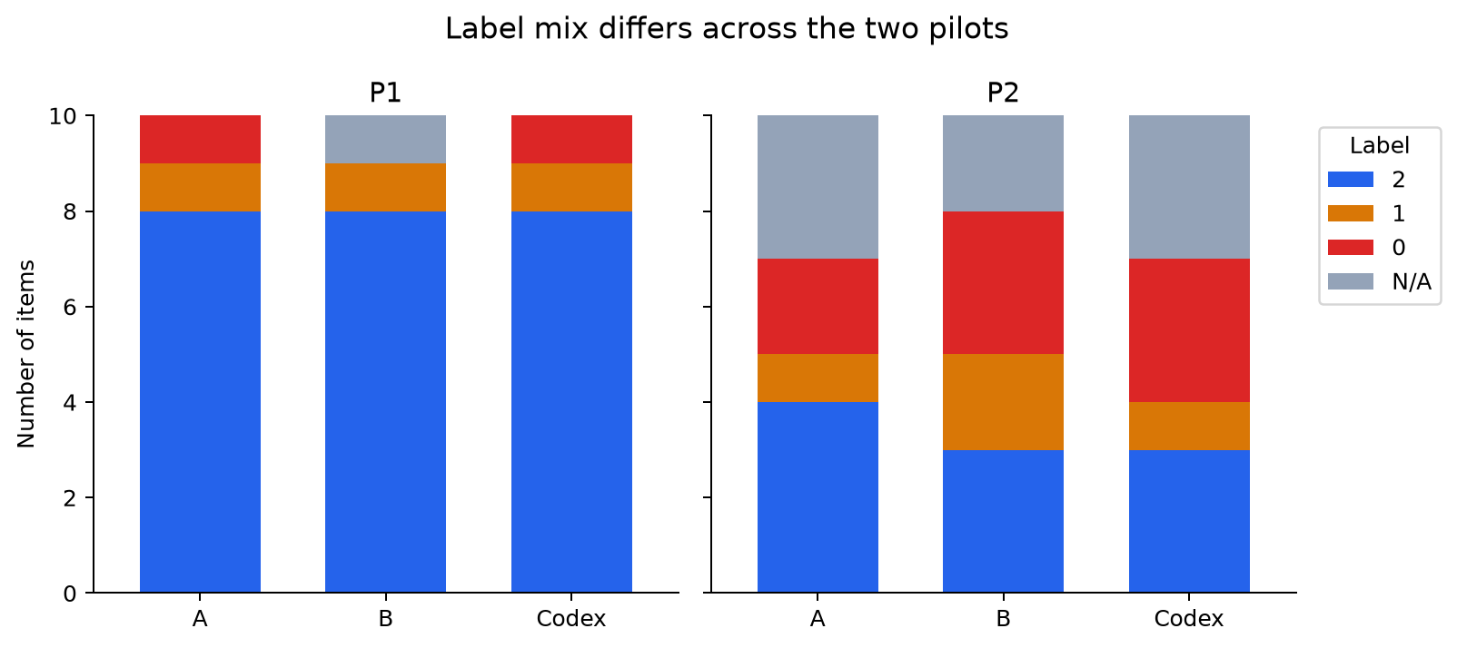
Figure 4. The first pilot is dominated by label 2; the second includes more 0 and N/A labels. This difference matters when interpreting kappa across rounds.

5. Core Python: recompute the main results
The following code reproduces the main agreement table and a confusion matrix from the 20 saved labels. The linked notebook contains the full dataset with reasons, all four plots, assertions, model metadata and executed outputs. No new model call is made by this analysis code.
import pandas as pd
import matplotlib.pyplot as plt
from sklearn.metrics import cohen_kappa_score, confusion_matrix

# Original A/B labels are v0.1; Codex labels are frozen v0.2.
# Keep N/A as a literal category, not a missing value.
records = [
('P1-01', 'B4', '2', '2', '2'),
('P1-02', 'B2', '0', 'N/A', '0'),
('P1-03', 'B1', '2', '2', '2'),
('P1-04', 'B3', '2', '2', '2'),
('P1-05', 'B4', '2', '2', '2'),
('P1-06', 'B2', '2', '2', '2'),
('P1-07', 'B4', '2', '2', '2'),
('P1-08', 'B3', '2', '2', '2'),
('P1-09', 'B1', '2', '2', '2'),
('P1-10', 'B3', '1', '1', '1'),
('P2-01', 'B4', 'N/A', '1', 'N/A'),
('P2-02', 'B4', '2', '2', '2'),
('P2-03', 'B1', '2', '2', '2'),
('P2-04', 'B3', '0', '0', '0'),
('P2-05', 'B2', 'N/A', 'N/A', 'N/A'),
('P2-06', 'B1', '2', '2', '2'),
('P2-07', 'B3', '2', '0', '0'),
('P2-08', 'B3', '0', '0', '0'),
('P2-09', 'B2', '1', '1', '1'),
('P2-10', 'B1', 'N/A', 'N/A', 'N/A'),
]
df = pd.DataFrame(records, columns=["item_id", "behavior", "A", "B", "Codex"])
labels = ["2", "1", "0", "N/A"]
for left, right in [("A", "B"), ("Codex", "A"), ("Codex", "B")]:
matches = int((df[left] == df[right]).sum())
kappa = cohen_kappa_score(df[left], df[right], labels=labels)
print(left, "vs", right, f"{matches}/20", f"agreement={matches/20:.3f}",
f"kappa={kappa:.3f}")

matrix = confusion_matrix(df["Codex"], df["B"], labels=labels)
fig, ax = plt.subplots(figsize=(4, 4))
ax.imshow(matrix, cmap="Blues")
for i in range(4):
for j in range(4):
ax.text(j, i, str(matrix[i, j]), ha="center", va="center")
ax.set_xticks(range(4), labels)
ax.set_yticks(range(4), labels)
ax.set_xlabel("B (v0.1)")
ax.set_ylabel("Codex (v0.2)")
ax.set_title("Pilot agreement, not accuracy")
fig.tight_layout()
plt.show()

